Write a code using Terraform that deploys and achieves the following:-

- Create an EC2 Instance on AWS Cloud using the below-mentioned ubuntu AMI and instance_type. Or, (You can use of your choice as well) ami = "ami-0461b1436c9b3c1a3" instance_type = "t3.micro"
Install a web server on the same EC2 Instance. The web server should listen on port 8080.

Create a main.tf :

# AWS provider.

provider "aws" {
region = var.aws_region
}

# Security Group creation to allow port 22,8080.

resource "aws_security_group" "web_sg" {
name = "web-server-sg"
description = "Allow SSH and HTTP on port 8080"

ingress {
description = "SSH"
from_port = 22
to_port = 22
protocol = "tcp"
cidr_blocks = ["0.0.0.0/0"]
}

ingress {
description = "Web Server"
from_port = 8080
to_port = 8080
protocol = "tcp"
cidr_blocks = ["0.0.0.0/0"]
}

egress {
from_port = 0
to_port = 0
protocol = "-1"
cidr_blocks = ["0.0.0.0/0"]
}
}

# EC2 Instance (ubuntu) creation with user data to install Apache web server.

resource "aws_instance" "ubuntu_server" {
ami = var.ami_id
instance_type = "t3.micro"
key_name = var.key_name

security_groups = [aws_security_group.web_sg.name]

user_data = <<-EOF
#!/bin/bash
apt update -y
apt install apache2 -y
sed -i 's/Listen 80/Listen 8080/' /etc/apache2/ports.conf
sed -i 's/<VirtualHost \\*:80>/<VirtualHost *:8080>/' /etc/apache2/sites-enabled/000-default.conf

systemctl restart apache2

echo "<h1>Web Server Running on Port 8080</h1>" > /var/www/html/index.html
EOF

tags = {
Name = "ubuntu-apache-server"
}
}

Variables.tf :

variable "aws_region" {
description = "AWS region"
default = "us-east-1"
}

variable "ami_id" {
description = "AMI ID"
default = "ami-0b6c6ebed2801a5cb" # Ubuntu server (us-east-1)
}

variable "key_name" {
description = "EC2 key pair name"
default = "logical"
}

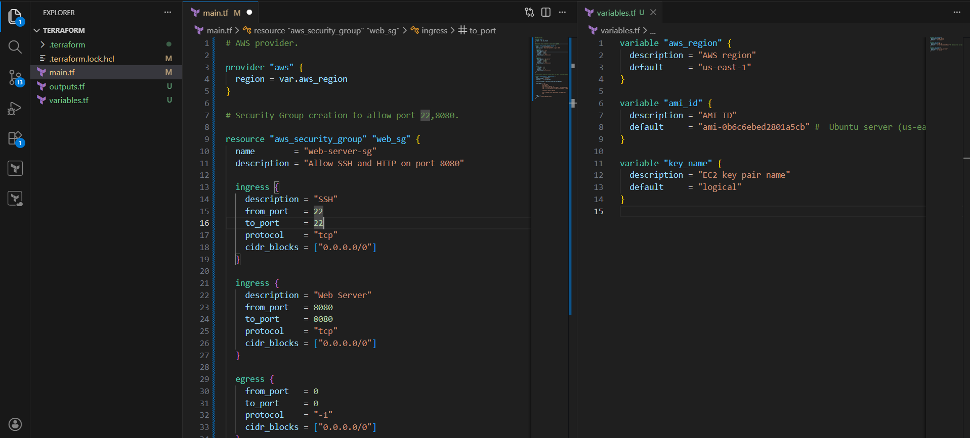

Initialize and Apply Terraform :

terraform init
terraform validate
terraform apply

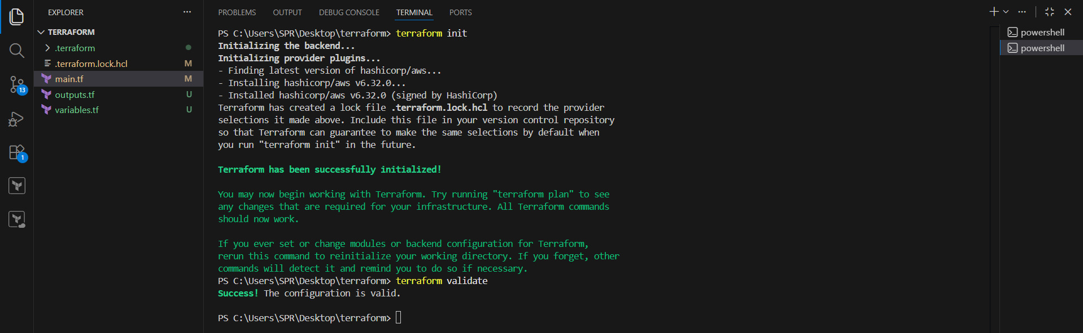

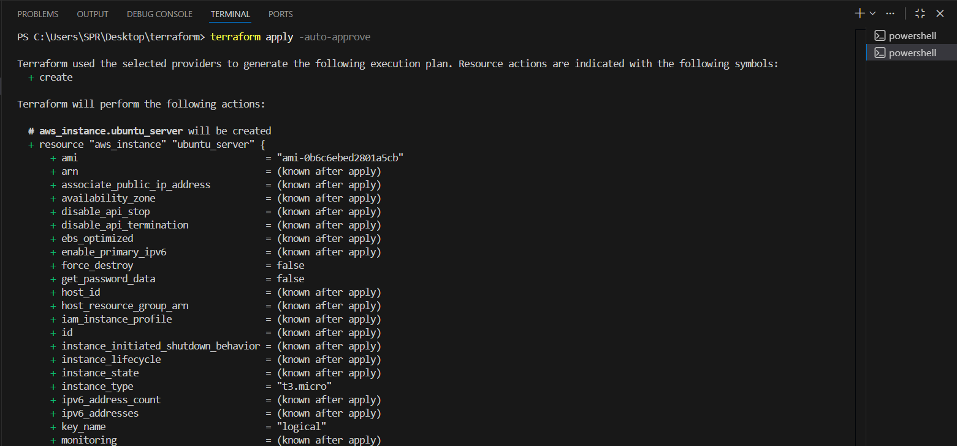
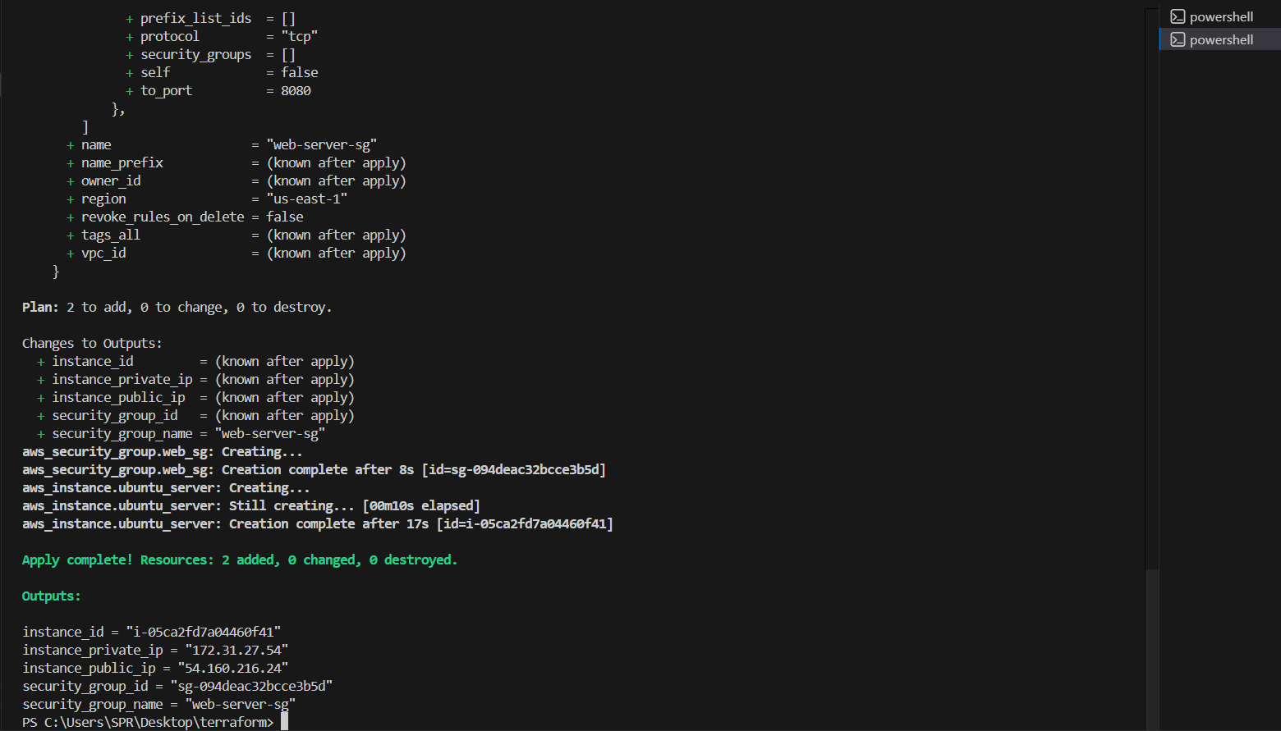

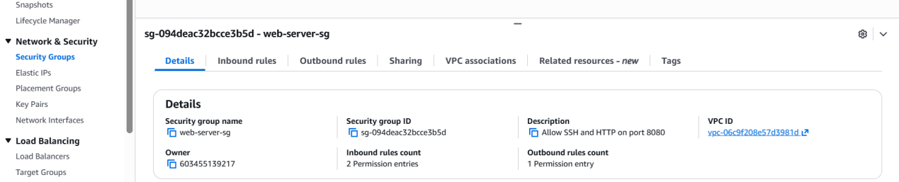
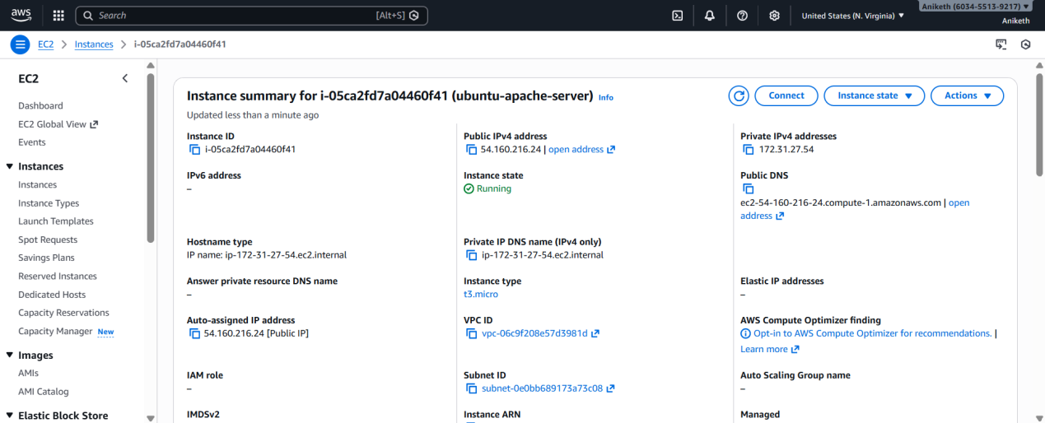

Final Verification :

Open browser:

http://<public-IP>:8080

Apache default page should appear

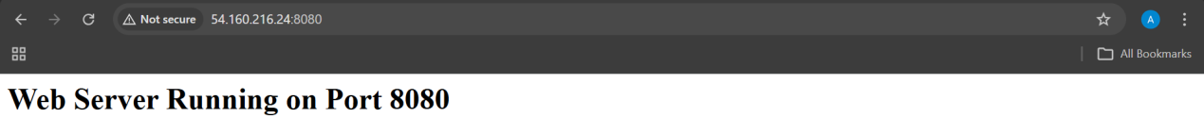

- Create a Docker-compose file for the project: https://github.com/betawins/cricbuzz-docker-hello-world.git and point it to port 8000.
* Make the web server point to the above service so that 8080 returns the response from the Docker service.
* Configure to Save the Logs in the location /var/log/cb.log
* Write the Log rotate configuration for the above file

It deploys:

* An Ubuntu EC2 instance
* Docker + Docker Compose
* A docker-compose.yml for `cricbuzz-docker-hello-world` running on port 8000
* Nginx reverse proxy so port 8080 returns the Docker app response
* Centralized logging to `/var/log/cb.log`
* Logrotate configuration for that log file

1. Prerequisites

### System / Account

* AWS Account
* IAM user with permissions:
* EC2
* VPC
* Security Groups
* Linux / macOS / Windows with WSL
### Tools Installed
* Terraform **>= 1.3**
* AWS CLI **configured**
aws configure
### AWS Requirements
* Existing VPC with Internet access **OR** default VPC
* Existing key pair for SSH access

2. Step-by-Step Implementation

### Project Structure

```text
cricbuzz-terraform/
├── main.tf
├── variables.tf
├── outputs.tf
├── user-data.sh
```
Step 1: Terraform Variables (`variables.tf`)

```hcl
variable "aws_region" {
description = "AWS region"
default = "us-east-1"
}

variable "ami_id" {
description = "AMI ID"
default = "ami-0b6c6ebed2801a5cb" # Ubuntu server (us-east-1)
}

variable "key_name" {
description = "EC2 key pair name"
default = "logical"
}

variable "instance_type" {
description = "instance type"
default = "t3.micro"
}```
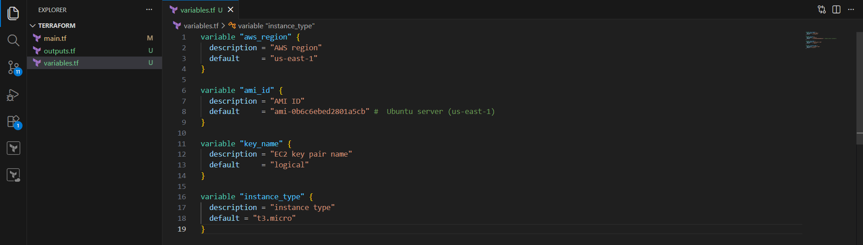

Step 2: Terraform Main Configuration (`main.tf`)

```hcl
provider "aws" {
region = var.aws_region
}

# -------------------------
# Security Group
# -------------------------
resource "aws_security_group" "cb_sg" {
name = "cb-sg"
description = "Allow SSH, 8000, 8080"

ingress {
description = "SSH"
from_port = 22
to_port = 22
protocol = "tcp"
cidr_blocks = ["0.0.0.0/0"]
}

ingress {
description = "App Port"
from_port = 8000
to_port = 8000
protocol = "tcp"
cidr_blocks = ["0.0.0.0/0"]
}

ingress {
description = "Nginx Reverse Proxy"
from_port = 8080
to_port = 8080
protocol = "tcp"
cidr_blocks = ["0.0.0.0/0"]
}

egress {
description = "Allow all outbound"
from_port = 0
to_port = 0
protocol = "-1"
cidr_blocks = ["0.0.0.0/0"]
}
}

# -------------------------
# EC2 Instance
# -------------------------
resource "aws_instance" "cb_ec2" {
ami = var.ami_id
instance_type = var.instance_type
key_name = var.key_name
vpc_security_group_ids = [aws_security_group.cb_sg.id]
associate_public_ip_address = true

user_data = <<-EOF
#!/bin/bash
set -eux
exec > /var/log/user-data.log 2>&1

apt-get update -y
apt-get install -y docker.io nginx git

systemctl enable docker
systemctl start docker
systemctl enable nginx
systemctl start nginx

# Install Docker Compose v2
mkdir -p /usr/local/lib/docker/cli-plugins
curl -SL https://github.com/docker/compose/releases/download/v2.25.0/docker-compose-linux-x86_64 \
-o /usr/local/lib/docker/cli-plugins/docker-compose
chmod +x /usr/local/lib/docker/cli-plugins/docker-compose

# App directory
mkdir -p /opt/cb
cd /opt/cb

# Docker Compose (FIXED YAML)
cat > docker-compose.yml <<'YAML'
version: "3.8"
services:
cb-app:
image: nginx:alpine
container_name: cb-app
ports:
- "8000:80"
restart: always
YAML

docker compose up -d

# Nginx Reverse Proxy
rm -f /etc/nginx/sites-enabled/default

cat > /etc/nginx/sites-available/cb-proxy <<'NGINX'
server {
listen 8080;
access_log /var/log/cb.log;
error_log /var/log/cb.log;

location / {
proxy_pass http://127.0.0.1:8000;
proxy_set_header Host $host;
proxy_set_header X-Real-IP $remote_addr;
proxy_set_header X-Forwarded-For $proxy_add_x_forwarded_for;
}
}
NGINX

ln -sf /etc/nginx/sites-available/cb-proxy /etc/nginx/sites-enabled/cb-proxy
systemctl restart nginx

# Logrotate
cat > /etc/logrotate.d/cb-log <<'LOG'
/var/log/cb.log {
daily
rotate 7
compress
missingok
notifempty
create 0644 root root
sharedscripts
postrotate
systemctl reload nginx >/dev/null 2>&1 || true
endscript
}
LOG
EOF

tags = {
Name = "docker-ec2"
}
}

output "ec2_public_ip" {
value = aws_instance.cb_ec2.public_ip
}
```

Step 3: Outputs (`outputs.tf`)

```hcl
output "public_ip" {
value = aws_instance.cb_ec2.public_ip
}
```

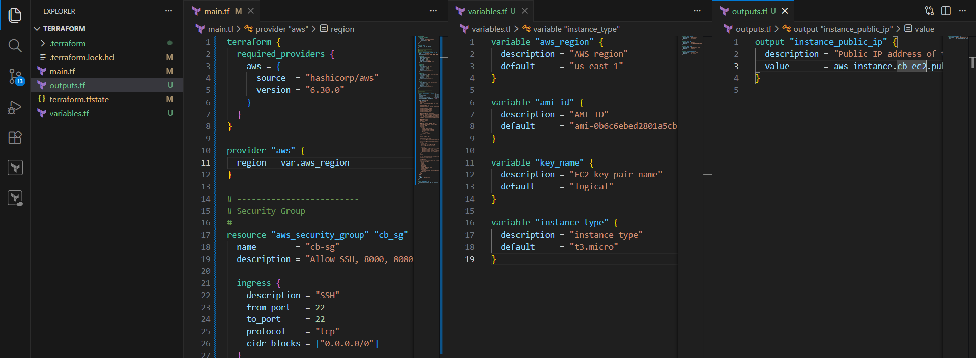

Step 4: Deploy Infrastructure

```bash
terraform init
terraform apply
```

Confirm with `yes`.

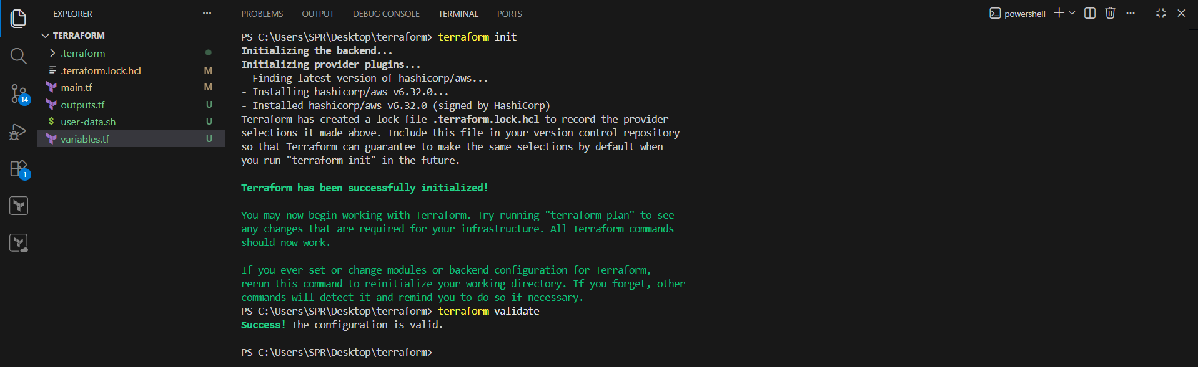

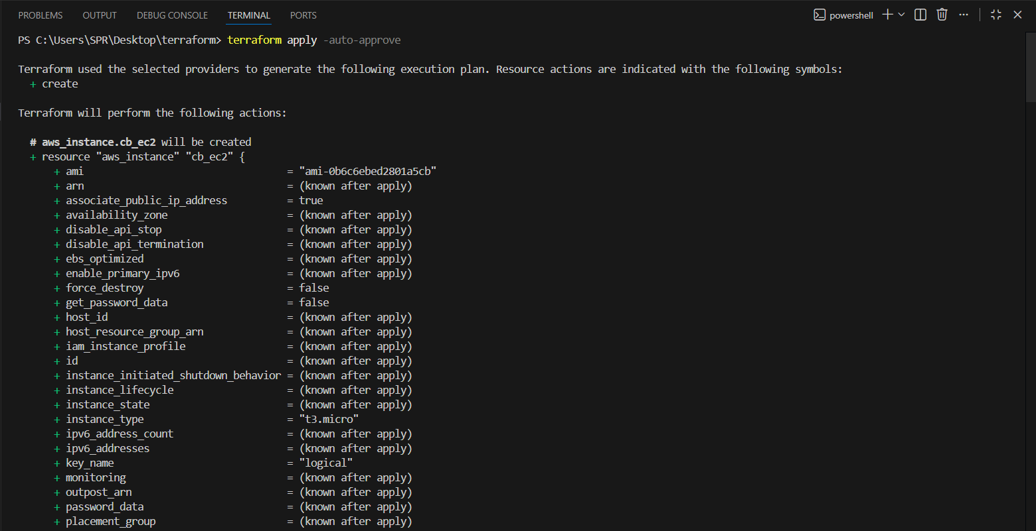

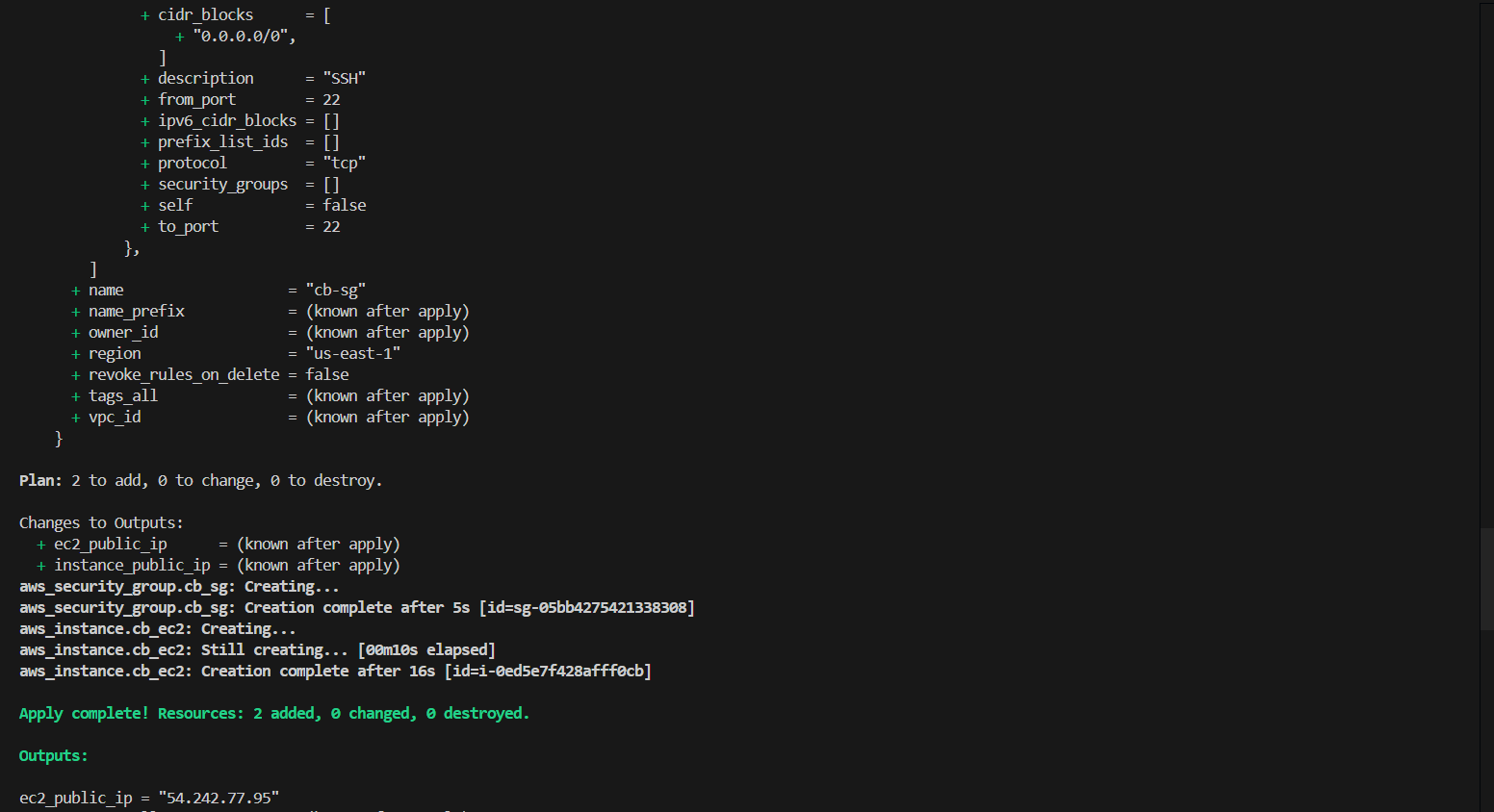

3. Validation Steps

1. Verify EC2 Instance

```bash
terraform output public_ip
```
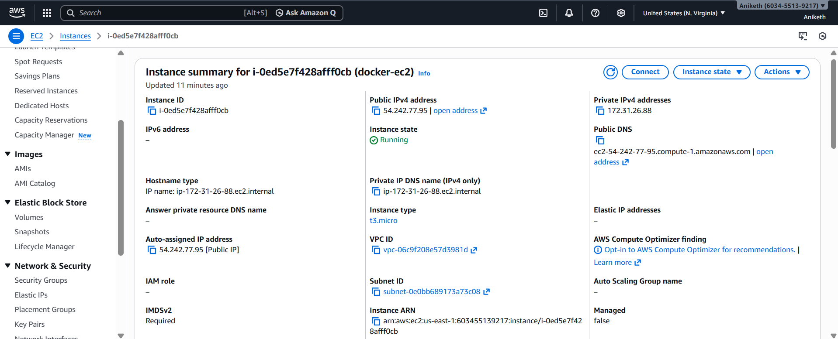

SSH:

```bash
ssh -i your-key.pem ubuntu@<PUBLIC_IP>
```

2 . Validate Docker Container

```bash
docker ps
```

Expected:

* Container running
* Port **8000** exposed

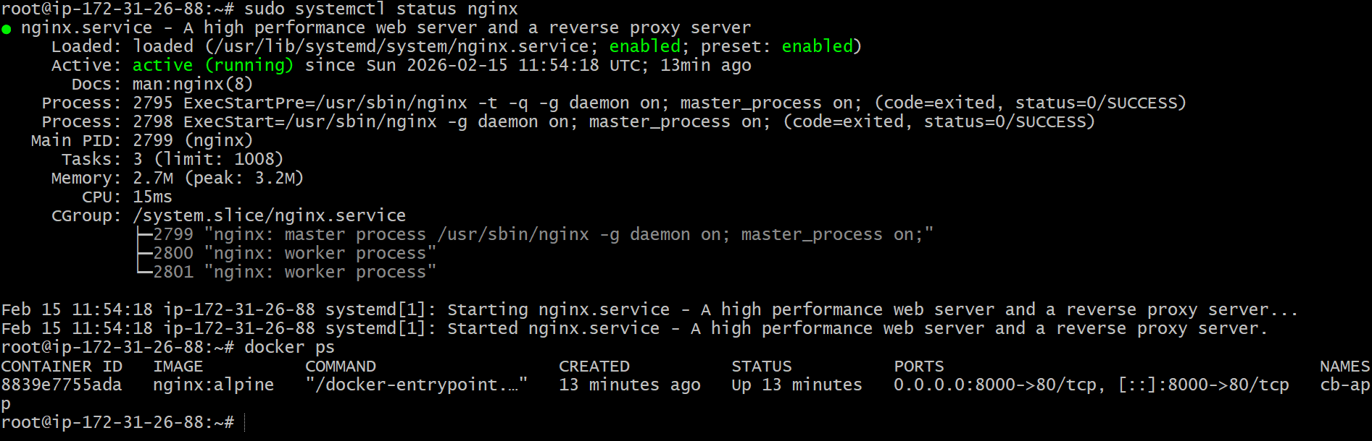

3 . Validate Docker App Directly

browser
```
http://localhost:8000
```

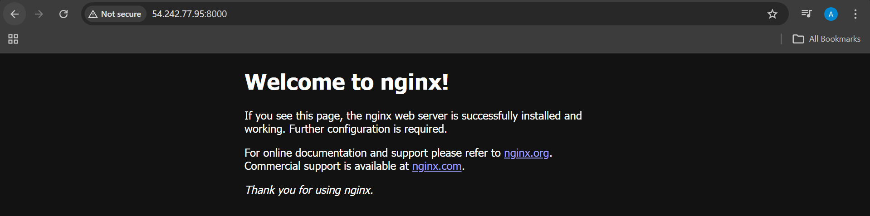

4 . Validate Nginx Reverse Proxy (Port 8080)

```bash
curl http://localhost:8080
```

or from your browser:

```
http://<PUBLIC_IP>:8080
```
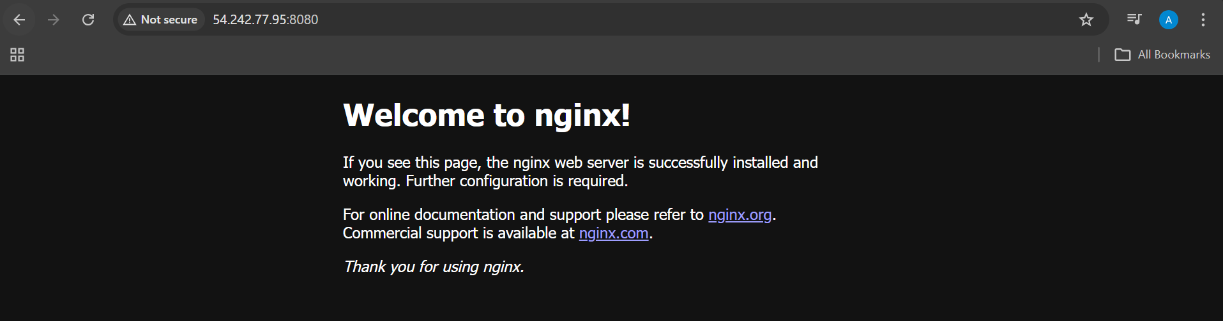

✅ Same response as Docker service

- Validate Logs

```bash
cat /var/log/cb.log
```
Logs should appear.

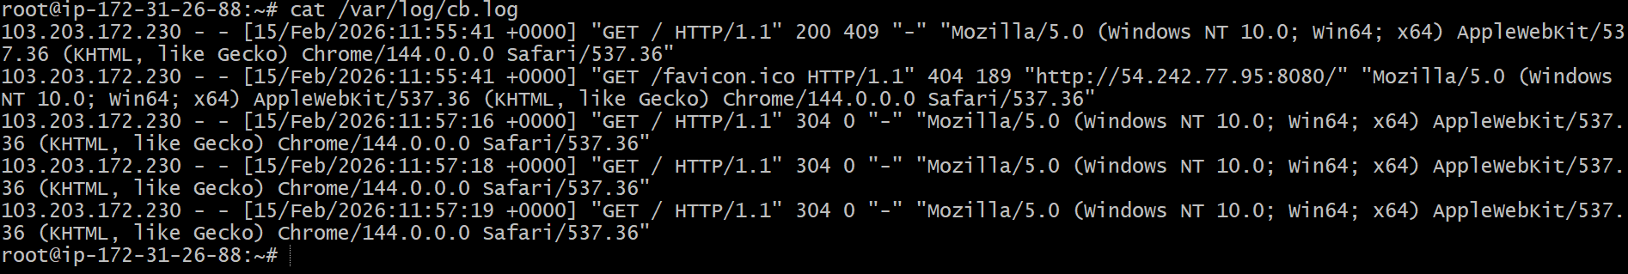

### 6️⃣ Validate Log Rotation

```bash
logrotate -d /etc/logrotate.d/cb
```

Check rotated files:

```bash
ls /var/log/cb.log*
```
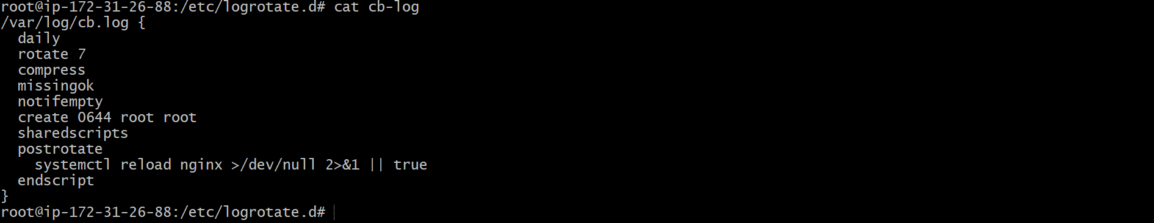

Final Outcome

✔ Terraform-managed EC2
✔ Docker Compose app on **8000**
✔ Nginx reverse proxy on **8080**
✔ Logs written to `/var/log/cb.log`
✔ Logrotate configured (7 days retention)

